**PROJECT REPORT**

**BLOCKCHAIN TECHNOLOGY FOR ELECTRONIC HEALTH RECORDS**

# INTRODUCTION

* 1. Project Overview
  2. Purpose

# LITERATURE SURVEY

* 1. Existing problem
  2. References
  3. Problem Statement Definition

# IDEATION & PROPOSED SOLUTION

* 1. Empathy Map Canvas
  2. Ideation & Brainstorming

# REQUIREMENT ANALYSIS

* 1. Functional requirement
  2. Non-Functional requirements

# PROJECT DESIGN

* 1. Data Flow Diagrams & User Stories
  2. Solution Architecture

# PROJECT PLANNING & SCHEDULING

* 1. Technical Architecture

# CODING & SOLUTIONING (Explain the features added in the project along with code)

* 1. Feature 1
  2. Feature 2

# PERFORMANCE TESTING

* 1. Performace Metrics

# RESULTS

* 1. Output Screenshots

# ADVANTAGES & DISADVANTAGES

1. **CONCLUSION**

# FUTURE SCOPE

1. **APPENDIX**

Source Code

GitHub & Project Demo Link

**ABSTRACT**

Electronic health records, or EHRs, are more popular than traditional paper-based medical records because of their efficiency, security, and ability to reduce redundant data. EHR interoperability is still lacking, and privacy concerns remain unsolved. Blockchain, a distributed ledger protocol made up of encrypted data blocks arranged in chains, offers a potential remedy for the privacy and interoperability issues with EHRs. In order to improve EHR interoperability and privacy protection, we define EHRs and blockchain technology in this article and provide a number of traditional blockchain-based schemes. Next, we go over the continued issues with system trust, equitable access, and effective data management.In order to establish EHRs based on blockchain technology, we propose in this commentary that health informatics, data sciences, and ethics continue to need research. Blockchain-based EHR schemes need to address potential healthcare resource inequality, the massive carbon footprint of computational needs, and potential mistrust of patients and health providers that may arise with wider use of blockchain technology.

**Keywords:** electronic health records, blockchain, interoperability, privacy

1. **INTRODUCTION**
   1. **Project Overview**

The computerized version of a patient's medical record that contains extremely sensitive private information about their history, diagnosis, and course of treatment is called an electronic health record, or EHR. Lab test results, billing and accounts, and appointments are common examples of additional EHR data that is kept on file. Among the early adopters of academic EHRs were Vanderbilt University, Indiana University, and the Mayo Clinic. VistA, the largest EHR system in the nation, was created by the federal government for Veterans Affairs Health Care in the 1970s. The popularity of HER increased by 1992 as a result of cheaper and more powerful hardware as well as advancements in computer technologies [1]. The apparent necessity to transfer medical records to electronic health records led to the incorporation of EHR into the Health Information Technology for Economic and Clinical Health Act (HITECH) in 2004.Beginning in 2009, the American Recovery and Reinvestment Act (ARRA, also known as "ObamaCare") made new incentives and resources accessible. By 2017, 95% of American hospitals were adopting electronic health record systems [2].

* Data Security and Privacy: Blockchain can enhance the security and privacy of EHRs. Patient data is stored in a decentralized and immutable ledger, making it more resistant to unauthorized access, data breaches, and tampering. Patients have greater control over who can access their records.
* Interoperability: Blockchain can facilitate the sharing of EHRs across different healthcare providers and systems. This can improve the continuity of care, reduce duplication of tests, and enhance collaboration among healthcare professionals.
* Data Integrity: Since blockchain records are tamper-proof and time-stamped, the integrity of EHRs is maintained. This can be crucial in ensuring the accuracy and trustworthiness of medical records.
* Patient-Centric Records: Blockchain technology can empower patients to have more control over their own health records. They can grant access to healthcare providers on a per-case basis, which enhances patient autonomy and involvement in their healthcare decisions.
* Streamlined Processes: Smart contracts on the blockchain can automate various processes related to EHRs, such as insurance claims, billing, and appointment scheduling. This can reduce administrative burdens and streamline healthcare operations.
* Reduced Costs: By eliminating intermediaries and reducing administrative overhead, blockchain technology can potentially reduce the cost of managing EHRs.
* Research and Analytics: EHR data stored on a blockchain can be made available for research while ensuring patient privacy. Researchers can access anonymized data with the consent of patients, potentially advancing medical research and public health initiatives.
* Disaster Recovery: Blockchain's decentralized nature ensures that EHR data is distributed across multiple nodes. This redundancy can improve data resilience and disaster recovery capabilities, ensuring that critical health data is not lost during emergencies.
* Auditability and Compliance: The transparency and immutability of blockchain records make it easier to audit healthcare transactions and ensure compliance with regulations, such as HIPAA (Health Insurance Portability and Accountability Act) in the United States.
* Patient Empowerment: Blockchain technology can empower patients to actively manage their health data and make informed decisions about its use. Patients can be more engaged in their healthcare, which can lead to better health outcomes.

1. **LITERATURE SURVEY**
   1. **Existing Problems**

The current method for managing electronic health records (EHRs) relies on centralized systems and data silos, resulting in limited data accessibility and sharing challenges among healthcare providers. Patients have minimal control over their records, and data security remains a concern, despite existing security measures. Data duplication, interoperability issues, and inefficiencies in healthcare processes are common. Implementing blockchain technology in EHR management aims to revolutionize this system. By utilizing blockchain, EHRs can become decentralized, secure, and patient-centric. Patients gain greater control over their records, data integrity is ensured through immutability, and smart contracts automate processes, reducing administrative overhead. The technology also facilitates data sharing among healthcare entities, streamlines operations, and supports research while adhering to regulatory requirements. Blockchain offers the potential to enhance data security, privacy, and overall healthcare efficiency.

* 1. **References**

1. Evans R.S. Electronic Health Records: Then, Now, and in the Future. Yearb. Med. Inform. 2016;25((Suppl. S1)):S48–S61. doi: 10.15265/IYS-2016-s006. [[PMC free article](https://www.ncbi.nlm.nih.gov/pmc/articles/PMC5171496/)] [[PubMed](https://pubmed.ncbi.nlm.nih.gov/27199197)] [[CrossRef](https://doi.org/10.15265%2FIYS-2016-s006" \t "_blank)] [[Google Scholar](https://scholar.google.com/scholar_lookup?journal=Yearb.+Med.+Inform.&title=Electronic+Health+Records:+Then,+Now,+and+in+the+Future&author=R.S.+Evans&volume=25&issue=(Suppl.+S1)&publication_year=2016&pages=S48-S61&pmid=27199197&doi=10.15265/IYS-2016-s006&)]
2. McBride S., Tietze M., Robichaux C., Stokes L., Weber E. Identifying and addressing ethical issues with use of electronic health records. Online J. Issues Nurs. 2018;23:1–4. doi: 10.3912/OJIN.Vol23No01Man05. [[CrossRef](https://doi.org/10.3912%2FOJIN.Vol23No01Man05" \t "_blank)] [[Google Scholar](https://scholar.google.com/scholar_lookup?journal=Online+J.+Issues+Nurs.&title=Identifying+and+addressing+ethical+issues+with+use+of+electronic+health+records&author=S.+McBride&author=M.+Tietze&author=C.+Robichaux&author=L.+Stokes&author=E.+Weber&volume=23&publication_year=2018&pages=1-4&doi=10.3912/OJIN.Vol23No01Man05&)]
3. Shahnaz A., Qamar U., Khalid A. Using blockchain for electronic health records. IEEE Access. 2019;7:147782–147795. doi: 10.1109/ACCESS.2019.2946373. [[CrossRef](https://doi.org/10.1109%2FACCESS.2019.2946373" \t "_blank)] [[Google Scholar](https://scholar.google.com/scholar_lookup?journal=IEEE+Access&title=Using+blockchain+for+electronic+health+records&author=A.+Shahnaz&author=U.+Qamar&author=A.+Khalid&volume=7&publication_year=2019&pages=147782-147795&doi=10.1109/ACCESS.2019.2946373&)]
4. Begoyan A. An Overview of Interoperability Standards for Electronic Health Records. Society For Design And Process Science; Dallas, TX, USA: 2007. [[Google Scholar](https://scholar.google.com/scholar_lookup?title=An+Overview+of+Interoperability+Standards+for+Electronic+Health+Records&author=A.+Begoyan&publication_year=2007&)]
5. Wachter S., Mittelstadt B., Russell C. Counterfactual Explanations without Opening the Black Box: Automated Decisions and the GDPR. SSRN J. 2017;31:814. doi: 10.2139/ssrn.3063289. [[CrossRef](https://doi.org/10.2139%2Fssrn.3063289" \t "_blank)] [[Google Scholar](https://scholar.google.com/scholar_lookup?journal=SSRN+J.&title=Counterfactual+Explanations+without+Opening+the+Black+Box:+Automated+Decisions+and+the+GDPR&author=S.+Wachter&author=B.+Mittelstadt&author=C.+Russell&volume=31&publication_year=2017&pages=814&doi=10.2139/ssrn.3063289&)]
6. Koczkodaj W.W., Mazurek M., Strzałka D., Wolny-Dominiak A., Woodbury-Smith M. Electronic Health Record Breaches as Social Indicators. Soc. Indic. Res. 2019;141:861–871. doi: 10.1007/s11205-018-1837-z. [[CrossRef](https://doi.org/10.1007%2Fs11205-018-1837-z" \t "_blank)] [[Google Scholar](https://scholar.google.com/scholar_lookup?journal=Soc.+Indic.+Res.&title=Electronic+Health+Record+Breaches+as+Social+Indicators&author=W.W.+Koczkodaj&author=M.+Mazurek&author=D.+Strza%C5%82ka&author=A.+Wolny-Dominiak&author=M.+Woodbury-Smith&volume=141&publication_year=2019&pages=861-871&doi=10.1007/s11205-018-1837-z&)]
7. Wikina S.B. What Caused the Breach? An Examination of Use of Information Technology and Health Data Breaches. Perspect. Health Inf. Manag. 2014;11:1. [[PMC free article](https://www.ncbi.nlm.nih.gov/pmc/articles/PMC4272442/)] [[PubMed](https://pubmed.ncbi.nlm.nih.gov/25593574)] [[Google Scholar](https://scholar.google.com/scholar_lookup?journal=Perspect.+Health+Inf.+Manag.&title=What+Caused+the+Breach?+An+Examination+of+Use+of+Information+Technology+and+Health+Data+Breaches&author=S.B.+Wikina&volume=11&publication_year=2014&pages=1&)]
8. Nakamoto S. Bitcoin: A peer-to-peer electronic cash system. Decentralized Bus. Rev. 2008;4:21260. [[Google Scholar](https://scholar.google.com/scholar_lookup?journal=Decentralized+Bus.+Rev.&title=Bitcoin:+A+peer-to-peer+electronic+cash+system&author=S.+Nakamoto&volume=4&publication_year=2008&pages=21260&)]
9. Yaga D., Mell P., Roby N., Scarfone K. Blockchain Technology Overview. arXiv. 2019 doi: 10.6028/NIST.IR.8202.190611078 [[CrossRef](https://doi.org/10.6028%2FNIST.IR.8202" \t "_blank)] [[Google Scholar](https://scholar.google.com/scholar_lookup?journal=arXiv&title=Blockchain+Technology+Overview&author=D.+Yaga&author=P.+Mell&author=N.+Roby&author=K.+Scarfone&publication_year=2019&doi=10.6028/NIST.IR.8202&)]
10. Azaria A., Ekblaw A., Vieira T., Lippman A. MedRec: Using Blockchain for Medical Data Access and Permission Management; Proceedings of the 2016 2nd International Conference on Open and Big Data (OBD); Vienna, Austria. 22–24 August 2016; pp. 25–30. [[CrossRef](https://doi.org/10.1109%2FOBD.2016.11" \t "_blank)] [[Google Scholar](https://scholar.google.com/scholar_lookup?journal=Proceedings+of+the+2016+2nd+International+Conference+on+Open+and+Big+Data+(OBD)&title=MedRec:+Using+Blockchain+for+Medical+Data+Access+and+Permission+Management&author=A.+Azaria&author=A.+Ekblaw&author=T.+Vieira&author=A.+Lippman&pages=25-30&doi=10.1109/OBD.2016.11&)]
11. Ancile: Privacy-Preserving Framework for Access Control and Interoperability of Electronic Health Records Using Blockchain Technology-ScienceDirect. [(accessed on 29 November 2021)]. Available online: <https://www.sciencedirect.com/science/article/pii/S2210670717310685>
12. OmniPHR: A Distributed Architecture Model to Integrate Personal Health Records-ScienceDirect. [(accessed on 29 November 2021)]. Available online: <https://www.sciencedirect.com/science/article/pii/S1532046417301089>
13. Griggs K.N., Ossipova O., Kohlios C.P., Baccarini A.N., Howson E.A., Hayajneh T. Healthcare Blockchain System Using Smart Contracts for Secure Automated Remote Patient Monitoring. J. Med. Syst. 2018;42:130. doi: 10.1007/s10916-018-0982-x. [[PubMed](https://pubmed.ncbi.nlm.nih.gov/29876661)] [[CrossRef](https://doi.org/10.1007%2Fs10916-018-0982-x" \t "_blank)] [[Google Scholar](https://scholar.google.com/scholar_lookup?journal=J.+Med.+Syst.&title=Healthcare+Blockchain+System+Using+Smart+Contracts+for+Secure+Automated+Remote+Patient+Monitoring&author=K.N.+Griggs&author=O.+Ossipova&author=C.P.+Kohlios&author=A.N.+Baccarini&author=E.A.+Howson&volume=42&publication_year=2018&pages=130&pmid=29876661&doi=10.1007/s10916-018-0982-x&)]
14. Yue X., Wang H., Jin D., Li M., Jiang W. Healthcare Data Gateways: Found Healthcare Intelligence on Blockchain with Novel Privacy Risk Control. J. Med. Syst. 2016;40:218. doi: 10.1007/s10916-016-0574-6. [[PubMed](https://pubmed.ncbi.nlm.nih.gov/27565509)] [[CrossRef](https://doi.org/10.1007%2Fs10916-016-0574-6" \t "_blank)] [[Google Scholar](https://scholar.google.com/scholar_lookup?journal=J.+Med.+Syst.&title=Healthcare+Data+Gateways:+Found+Healthcare+Intelligence+on+Blockchain+with+Novel+Privacy+Risk+Control&author=X.+Yue&author=H.+Wang&author=D.+Jin&author=M.+Li&author=W.+Jiang&volume=40&publication_year=2016&pages=218&pmid=27565509&doi=10.1007/s10916-016-0574-6&)]
15. Xia Q., Sifah E.B., Asamoah K.O., Gao J., Du X., Guizani M. MeDShare: Trust-Less Medical Data Sharing Among Cloud Service Providers via Blockchain. IEEE Access. 2017;5:14757–14767. doi: 10.1109/ACCESS.2017.2730843. [[CrossRef](https://doi.org/10.1109%2FACCESS.2017.2730843" \t "_blank)] [[Google Scholar](https://scholar.google.com/scholar_lookup?journal=IEEE+Access&title=MeDShare:+Trust-Less+Medical+Data+Sharing+Among+Cloud+Service+Providers+via+Blockchain&author=Q.+Xia&author=E.B.+Sifah&author=K.O.+Asamoah&author=J.+Gao&author=X.+Du&volume=5&publication_year=2017&pages=14757-14767&doi=10.1109/ACCESS.2017.2730843&)]
16. Jain M., Pandey D., Sharma K.K. Advances in Data Computing, Communication and Security. Springer; Singapore: 2022. A Granular Access-Based Blockchain System to Prevent Fraudulent Activities in Medical Health Records; pp. 635–645. [[Google Scholar](https://scholar.google.com/scholar_lookup?title=Advances+in+Data+Computing,+Communication+and+Security&author=M.+Jain&author=D.+Pandey&author=K.K.+Sharma&publication_year=2022&)]
17. Ktari J., Frikha T., Ben Amor N., Louraidh L., Elmannai H., Hamdi M. IoMT-based platform for E-health monitoring based on the blockchain. Electronics. 2022;11:2314. doi: 10.3390/electronics11152314. [[CrossRef](https://doi.org/10.3390%2Felectronics11152314" \t "_blank)] [[Google Scholar](https://scholar.google.com/scholar_lookup?journal=Electronics&title=IoMT-based+platform+for+E-health+monitoring+based+on+the+blockchain&author=J.+Ktari&author=T.+Frikha&author=N.+Ben+Amor&author=L.+Louraidh&author=H.+Elmannai&volume=11&publication_year=2022&pages=2314&doi=10.3390/electronics11152314&)]
18. Harshini Poojaa K., Ganesh Kumar S. Scalability Challenges and Solutions in Blockchain Technology. In: Smys S., Balas V.E., Palanisamy R., editors. Inventive Computation and Information Technologies. Springer; Singapore: 2022. pp. 595–606. Lecture Notes in Networks and Systems. [[CrossRef](https://doi.org/10.1007%2F978-981-16-6723-7_44" \t "_blank)] [[Google Scholar](https://scholar.google.com/scholar_lookup?title=Inventive+Computation+and+Information+Technologies&author=K.+Harshini+Poojaa&author=S.+Ganesh+Kumar&publication_year=2022&)]
19. Wen X.J., Chen Y.Z., Fan X.C., Zhang W., Yi Z.Z., Fang J.B. Blockchain consensus mechanism based on quantum zero-knowledge proof. Opt. Laser Technol. 2022;147:107693. doi: 10.1016/j.optlastec.2021.107693. [[CrossRef](https://doi.org/10.1016%2Fj.optlastec.2021.107693" \t "_blank)] [[Google Scholar](https://scholar.google.com/scholar_lookup?journal=Opt.+Laser+Technol.&title=Blockchain+consensus+mechanism+based+on+quantum+zero-knowledge+proof&author=X.J.+Wen&author=Y.Z.+Chen&author=X.C.+Fan&author=W.+Zhang&author=Z.Z.+Yi&volume=147&publication_year=2022&pages=107693&doi=10.1016/j.optlastec.2021.107693&)]
20. Park Y.R., Lee E., Na W., Park S., Lee Y., Lee J.H. Is Blockchain Technology Suitable for Managing Personal Health Records? Mixed-Methods Study to Test Feasibility. J. Med. Internet Res. 2019;21:e12533. doi: 10.2196/12533. [[PMC free article](https://www.ncbi.nlm.nih.gov/pmc/articles/PMC6384539/)] [[PubMed](https://pubmed.ncbi.nlm.nih.gov/30735142)] [[CrossRef](https://doi.org/10.2196%2F12533" \t "_blank)] [[Google Scholar](https://scholar.google.com/scholar_lookup?journal=J.+Med.+Internet+Res.&title=Is+Blockchain+Technology+Suitable+for+Managing+Personal+Health+Records?+Mixed-Methods+Study+to+Test+Feasibility&author=Y.R.+Park&author=E.+Lee&author=W.+Na&author=S.+Park&author=Y.+Lee&volume=21&publication_year=2019&pages=e12533&pmid=30735142&doi=10.2196/12533&)]
21. Bitcoin’s Growing Energy Problem-ScienceDirect. [(accessed on 7 March 2022)]. Available online: <https://www.sciencedirect.com/science/article/pii/S2542435118301776>
22. The Future of Cryptocurrencies: Bitcoin and Beyond|Nature. [(accessed on 7 March 2022)]. Available online: <https://www.nature.com/articles/526021a>
23. Krause M.J., Tolaymat T. Quantification of energy and carbon costs for mining cryptocurrencies. Nat. Sustain. 2018;1:711–718. doi: 10.1038/s41893-018-0152-7. [[CrossRef](https://doi.org/10.1038%2Fs41893-018-0152-7" \t "_blank)] [[Google Scholar](https://scholar.google.com/scholar_lookup?journal=Nat.+Sustain.&title=Quantification+of+energy+and+carbon+costs+for+mining+cryptocurrencies&author=M.J.+Krause&author=T.+Tolaymat&volume=1&publication_year=2018&pages=711-718&doi=10.1038/s41893-018-0152-7&)]
    1. **Problem Statement and Definition**

The problem at hand revolves around the inefficiencies, security concerns, and lack of patient control in the current electronic health records (EHRs) management system. Traditional EHRs are centralized, leading to data silos, hindering the seamless exchange of information between healthcare providers. This results in duplicate tests, increased costs, and suboptimal patient care. Security breaches and unauthorized access to patient data pose serious risks. Additionally, patients have limited involvement and control over their EHRs, which can impact their healthcare decisions and privacy. The challenge is to create a secure, interoperable, and patient-centric EHR system that leverages blockchain technology. This system should empower patients, ensure data integrity, streamline healthcare processes, and facilitate data sharing while adhering to regulatory requirements.

The problem statement is, therefore, to design and implement a blockchain-based EHR management solution that overcomes the limitations of the existing system, ultimately improving healthcare efficiency and patient care.

**Problem Statement:** This is a statement that articulates a problem, need, or opportunity that requires attention or a solution. It typically outlines the current state of affairs and highlights any shortcomings, issues, or gaps in the existing system or process. A well-crafted problem statement is specific, measurable, and relevant to the project's objectives. It should answer questions like what the problem is, who is affected by it, when and where it occurs, and why it's a problem.

**Problem Definition:** Once the problem is stated, the problem definition delves deeper into the problem, providing a more comprehensive understanding. It may include the following components:

Scope: This defines the boundaries of the problem. What aspects of the problem are included, and what are excluded from consideration?

Context: Understanding the context in which the problem occurs is crucial. This might involve discussing the industry, market, or relevant policies and regulations.

broader community. This could include financial, social, or operational impacts.

Causes and Contributing Factors: Identifying the root causes and factors that contribute to the problem. This helps in understanding why the problem exists in the first place.

Goals and Objectives: Clearly stating what the project aims to achieve in addressing the problem. This could include specific outcomes, performance metrics, or targets.

Constraints and Limitations: Acknowledging any constraints or limitations, such as budgetary, technological, or resource constraints, that might affect the project's approach to solving the problem.

1. **IDEATION AND PROPOSED SOLUTION**
   1. **Empathy Map Canvas**

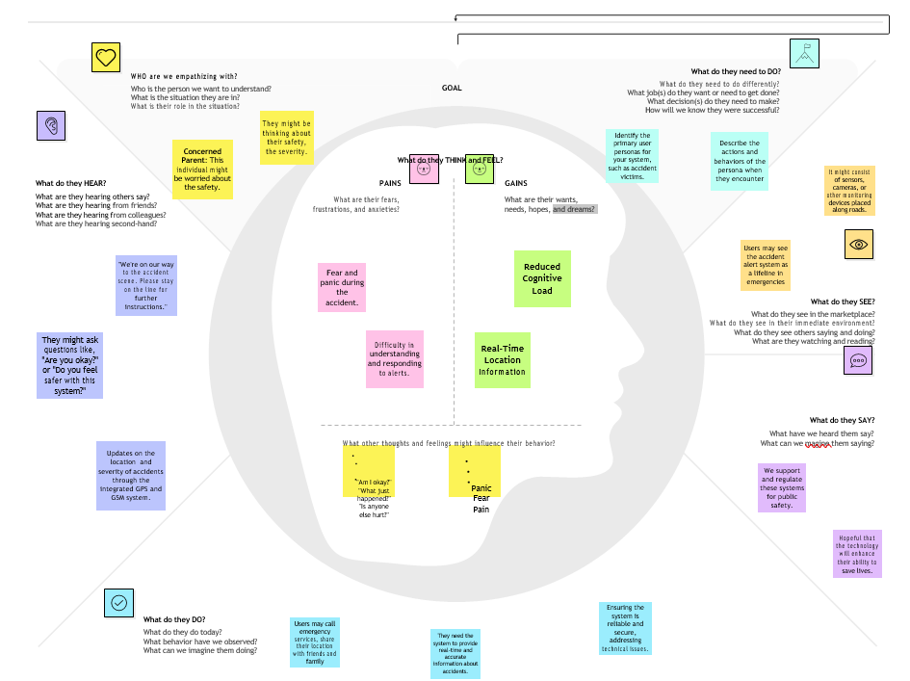

* 1. **ideation & Brainstroming**

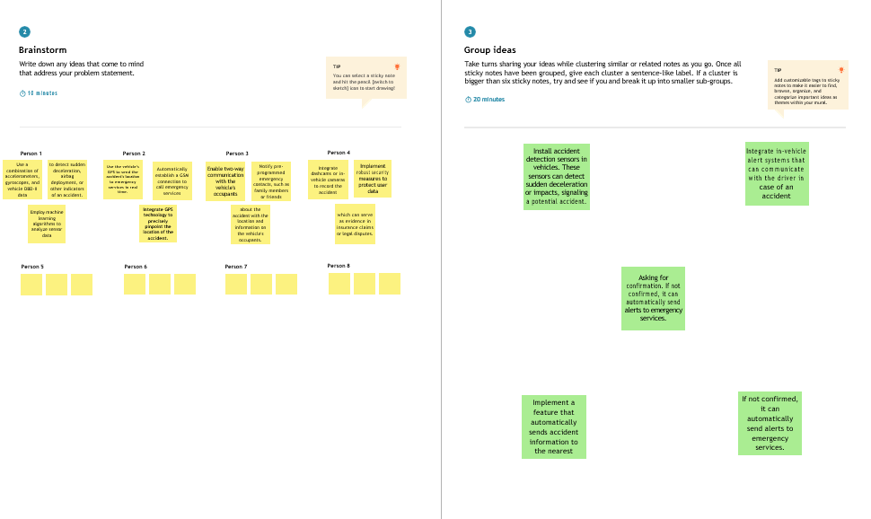****

1. **REQUIREMENT ANALYSIS**
   1. **Functional Requirements**

* **User Registration and Authentication:** Users, including healthcare providers and patients, should be able to register and authenticate their identities securely to access the system.
* **EHR Creation and Storage:** The system should allow authorized users to create, upload, and securely store electronic health records on the blockchain. This includes various types of medical data, such as medical history, test results, and treatment records.
* **Access Control and Permissions:** Implement robust access control mechanisms to ensure that only authorized individuals or entities can access and modify EHRs. Patients should have control over who can access their records.
* **Interoperability:** Enable the sharing of EHRs across different healthcare providers and systems. Ensure that the system can communicate with and accept data from various existing EHR systems.
* **Data Encryption:** All EHR data should be encrypted to ensure its confidentiality and integrity. This is essential for maintaining patient privacy.
* **Data Integrity and Immutability**: Guarantee the integrity of EHR data by making it tamper-proof through blockchain technology. Once recorded, data should be immutable and timestamped.
* **Smart Contracts:** Implement smart contracts to automate processes such as insurance claims, billing, and appointment scheduling. These contracts should execute actions based on predefined conditions.
* **Patient Consent Management:** Develop a system for patients to give explicit consent for healthcare providers to access their records. This should include fine-grained control over what data is shared.
* **Audit Trail and Logging:** Maintain a comprehensive audit trail to track all actions related to EHRs. This is crucial for auditing, compliance, and accountability.
* **Search and Retrieval:** Enable efficient search and retrieval of EHRs for authorized users. This includes advanced search features to locate specific records quickly.
  1. **Non Functional Requirements**
* **Security:** Ensure the highest level of security for EHR data through encryption, access controls, and secure communication protocols. The system should be resilient to cyberattackauthorized individuals to access patient records and ensuring that patient consent is obtained for data sharing.
* **Scalability:** The system should be able to scale to accommodate a growing number of EHRs and users, Privacy: Guarantee strict privacy protection in compliance with healthcare regulations, enabling only particularly in healthcare organizations with large patient populations.
* **Performance:** Maintain high system performance to ensure that users can access EHRs quickly and without delays. Response times for queries and transactions should be minimal.
* **Availability:** The system should be highly available, with minimal downtime. It should also have a disaster recovery plan in place to ensure data is not lost in the event of system failures or disasters.
* **Interoperability:** Ensure compatibility with various EHR systems and data standards to support data exchange and sharing between different healthcare providers.
* **Compliance:** Adhere to relevant healthcare regulations, data protection laws, and industry standards, such as HIPAA, GDPR, and blockchain best practices.
* **Auditability:** Maintain detailed logs and audit trails of all interactions with EHRs, allowing for comprehensive tracking of data access and modifications.
* **User Experience:** Design an intuitive and user-friendly interface for healthcare providers and patients to access and manage EHRs. Training and support should be readily available.
* **Data Backup and Recovery:** Implement a robust data backup and recovery system to ensure data is protected and recoverable in case of data loss or system failures.

**PROJECT DESIGN**

* 1. **Solution Architecture Diagram**

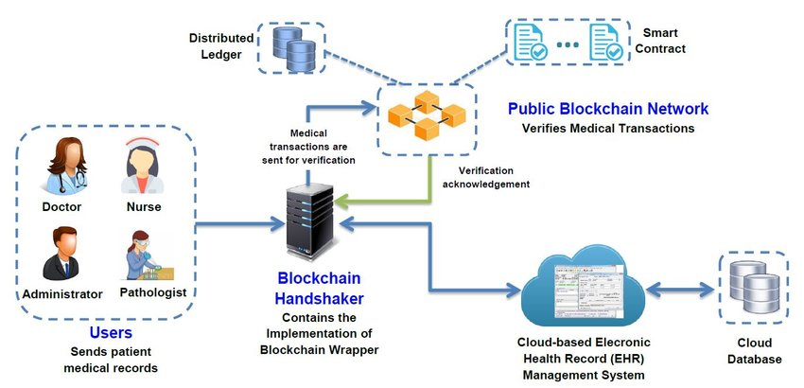

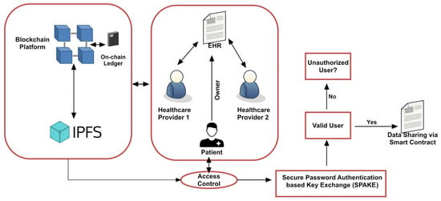

1. **PROJECT PLANNING**
   1. **Technical Architecture**

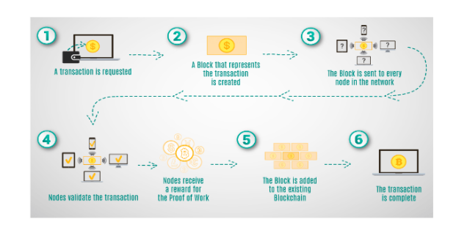

1. **CODING & SOLUTIONING**

Blockchain technology is a decentralized way of storing and sharing information. It's a distributed ledger where records are stored in a linked sequence of blocks. The records are theoretically difficult to delete or tamper with.

**Blockchain technology can be used for electronic health records (EHRs):**

1. **Encryption**

Smart sensors collect the user's health information, which is then encrypted and stored in the nodes of the Ethereum blockchain.

1. **Data security**

Blockchain technology can help manage and secure patient data into a single record held by the patient.

1. **Data sharing**

Blockchain technology can be used to achieve data sharing with security and privacy preservation.

**Blockchain technology has the following advantages:**

* It's decentralized
* It's encrypted
* It's difficult to delete or tamper with
* It has the potential to enhance the confidentiality and integrity of EHRs

An EHR is an electronic version of a patient's medical history. It can include information such as: Demographics, Progress notes, Problems, Medications.

**Contract Definition**

Creating a smart contract for managing electronic health records (EHRs) on a blockchain is a complex task and typically involves several layers of technology, including front-end and back-end components. Here's a simplified smart contract definition for EHR management, followed by an overview of the **front-end development process:**

**Smart Contract Definition:**

// SPDX-License-Identifier: MIT

pragma solidity ^0.8.0;

contract EHRManagement {

// Define the structure for an Electronic Health Record (EHR)

struct HealthRecord {

string patientName;

uint256 birthDate;

string medicalHistory;

string treatmentRecord;

// Add more relevant data fields as needed

}

// Mapping to associate patient addresses with their EHRs

mapping(address => HealthRecord) private patientRecords;

// Function to create or update a patient's EHR

function createOrUpdateEHR(

string memory \_patientName,

uint256 \_birthDate,

string memory \_medicalHistory,

string memory \_treatmentRecord

) public {

// Update the EHR for the sender's address

patientRecords[msg.sender] = HealthRecord({

patientName: \_patientName,

birthDate: \_birthDate,

medicalHistory: \_medicalHistory,

treatmentRecord: \_treatmentRecord

});

}

// Function to retrieve a patient's EHR

function getEHR() public view returns (

string memory patientName,

uint256 birthDate,

string memory medicalHistory,

string memory treatmentRecord

) {

HealthRecord memory ehr = patientRecords[msg.sender];

return (

ehr.patientName,

ehr.birthDate,

ehr.medicalHistory,

ehr.treatmentRecord

);

}

// Add more functions for consent management, data sharing, and other EHR-related actions

}

**7.1 Front-End Development:**

Front-end development involves creating a user-friendly interface for patients and healthcare providers to interact with the blockchain-based EHR system. Here's a simplified overview of the front-end **development process:**

**User Interface (UI) Design**

Design an intuitive and responsive user interface that allows users to log in, manage their EHRs, grant or revoke consent, and access their records.

**User Authentication**

Implement secure user authentication, such as login credentials or biometric authentication, to ensure only authorized users can access the system.

**Consent Management**

Create features that allow patients to manage their consent preferences, specifying who can access their EHRs and for what purposes.

**Data Entry and Retrieval**

Develop forms for patients and healthcare providers to enter and retrieve EHR data. Ensure that data is encrypted before being transmitted to and from the blockchain.

**Data Display**

Display EHR data in a readable format, allowing users to view their records, medical history, and treatment information.

**Transaction Monitoring**

Provide users with the ability to monitor transactions, see who accessed their data, and when those actions occurred.

**Reporting**

Implement reporting features for healthcare providers and administrators to generate compliance reports, access audit logs, and analyze EHR data.

**Notifications**

Include a notification system to alert users about changes to their EHRs, appointments, or consent requests.

**User Support**

Offer user support resources, including FAQs, user guides, and a helpdesk to assist users with any questions or issues.

**Testing and Quality Assurance**

Thoroughly test the front-end application to ensure its functionality, security, and user-friendliness.

**Deployment**

Deploy the front-end application on a secure web server or as a mobile app, making it accessible to users.

**7.2 Features**

A project involving the implementation of blockchain technology in electronic health record (EHR) management should encompass a range of features to address the diverse needs of healthcare providers, patients, and regulatory requirements. Here are key features of such a project:

User Authentication

Ensure secure user authentication to verify the identity of healthcare providers and patients accessing the system.

**Patient Registration**

Enable patients to register and create their accounts securely.

**EHR Creation and Updating**

Allow healthcare providers to create, update, and maintain EHRs for patients, recording medical history, test results, and treatment information.

**Access Control**

Implement robust access control mechanisms to determine who can access, view, and modify patient EHRs.

**Consent Management**

Enable patients to specify consent preferences, granting or revoking access to their records for specific healthcare providers or research purposes.

**Interoperability**

Facilitate data exchange and interoperability with existing EHR systems to ensure seamless sharing of healthcare data between different providers.

**Smart Contracts**

Develop and integrate smart contracts to automate processes such as consent management, data sharing, appointment scheduling, and billing.

**Data Encryption**

Employ strong encryption protocols to protect the confidentiality and integrity of patient data.

**Data Immutability**

Ensure that once data is recorded on the blockchain, it is tamper-proof and timestamped for data integrity.

**Search and Retrieval**

Enable users to efficiently search for and retrieve specific EHRs and data, with advanced search features.

**User-Friendly Interface**

Create intuitive user interfaces for healthcare providers and patients to access, manage, and interact with EHRs.

**Audit Trail**

Maintain a detailed audit trail to track all interactions with EHRs, enhancing transparency and accountability.

**Notifications and Alerts**

Implement a notification system to keep users informed about updates to their EHRs, appointments, and consent requests.

**Reporting and Analytics**

Offer reporting and analytics features for healthcare providers and administrators to gain insights from the EHR data for research and decision-making.

**Patient Portability**

Allow patients to export their EHRs in a standard format for portability, enabling them to share records with other healthcare providers.

**Compliance with Regulations**

Ensure compliance with healthcare regulations and data protection laws, such as HIPAA, GDPR, or local healthcare data privacy requirements.

**Emergency Access**

Provide a secure protocol for emergency access to critical EHR data, ensuring it is time-limited and traceable.

**Data Backup and Recovery**

Implement a robust data backup and recovery system to protect against data loss or system failures.

**Scalability**

Design the system to handle a growing number of EHRs and users, particularly in healthcare organizations with large patient populations.

**Privacy and Security**

Prioritize user privacy and data security throughout the project, including secure storage, encryption, and access controls.

1. **PERFORMANCE TESTING**

|  |  |  |  |
| --- | --- | --- | --- |
| **S.No.** | **Parameter** | **Values** | **Screenshot** |
| 1. | Information gathering | Setup all the Prerequisite: |  |
| 2. | Extract the zip files | Open to vs code |  |
| 3. | Remix Ide platform explorting | Deploy the smart contract code  Deploy and run the transaction. By selecting the environment - inject the MetaMask. |  |
| 4 | Open file explorer | Open the extracted file and click on the folder.  Open src, and search for utiles.  Open cmd enter commands 1.npm install   1. npm bootstrap 2. npm start |  |
| 5 | {LOCALHOSTnIP ADDRESS | copy the address and open it to chrome so you can see the front end of your project. |  |

1. **RESULTS**

**9.1 Output Screenshot**

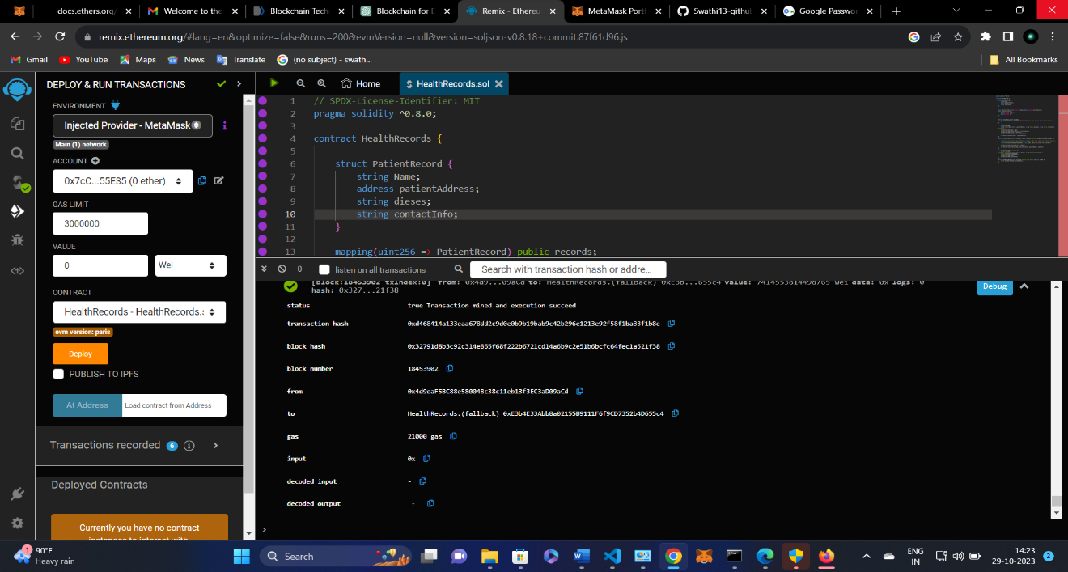

**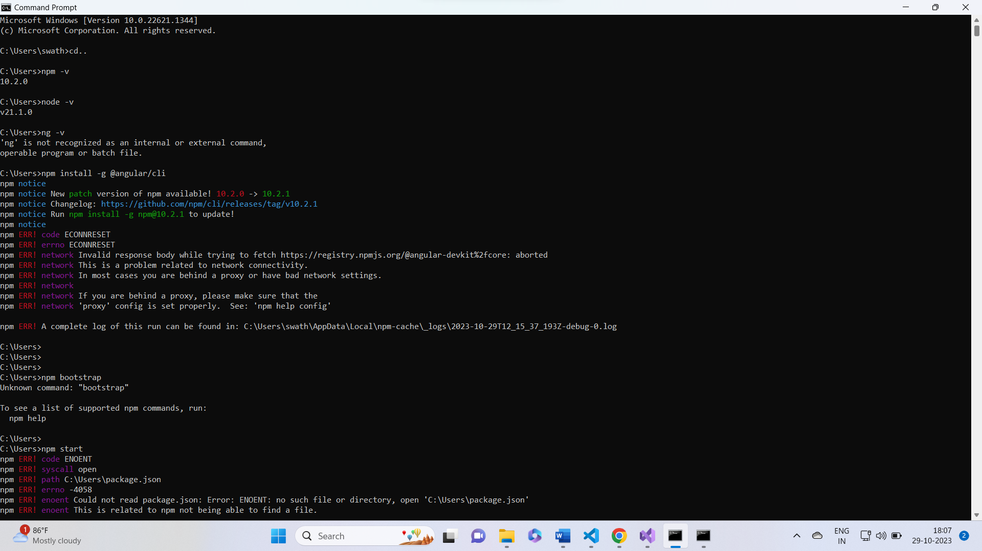**

**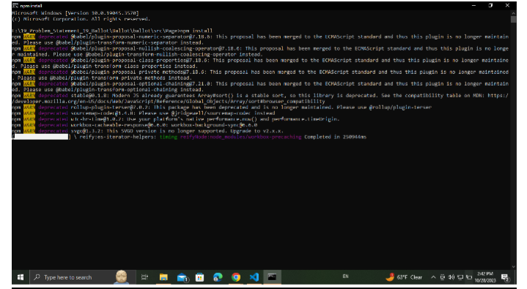**

**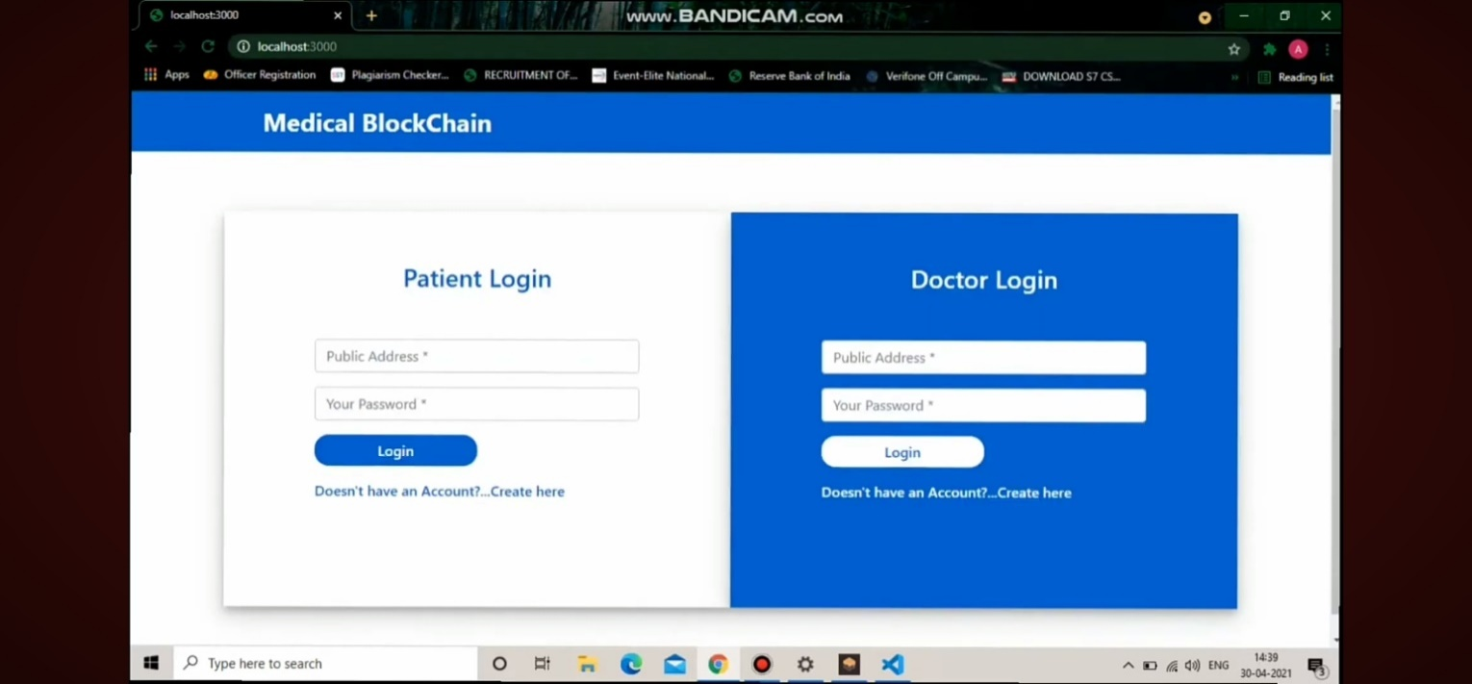**

**X. ADVANTAGES & DISADVANTAGE**

**10.1 Advantage**

* **Enhanced Data Security**: Blockchain's decentralized and immutable ledger enhances the security and integrity of EHRs. Patient data is protected from unauthorized access, tampering, and data breaches, which are significant concerns in traditional EHR systems.
* **Patient Empowerment:** Patients gain greater control over their health records. They can manage who can access their data and grant consent for specific purposes, putting them in charge of their healthcare information.
* **Improved Data Privacy:** Blockchain technology enhances data privacy by giving patients more control over their data. Patient confidentiality and privacy are better protected, aligning with data protection laws like HIPAA and GDPR.
* **Interoperability:** Blockchain can facilitate the sharing of EHRs across different healthcare providers and systems. This enhances care coordination, reduces duplication of tests, and improves healthcare collaboration.
* **Data Integrity**: EHR data stored on the blockchain is tamper-proof and time-stamped, ensuring the accuracy and reliability of medical records, which is vital for patient care and research.
* **Streamlined Processes:** Smart contracts automate various administrative processes, reducing paperwork and administrative overhead. This results in cost savings and more efficient healthcare operations.
* **Reduced Costs:** By eliminating intermediaries and reducing administrative burdens, blockchain can lead to cost savings in healthcare management.
* **Research and Analytics:** EHR data stored on a blockchain can be made available for research purposes while protecting patient privacy. This can advance medical research and public health initiatives.
* **Disaster Recovery:** The decentralized nature of blockchain ensures data redundancy and resilience, reducing the risk of data loss during emergencies or system failures.
* **Auditability and Compliance**: The transparency and immutability of blockchain records make it easier to audit healthcare transactions, ensuring compliance with healthcare regulations and data protection laws.

**10.2 Disadvantage**

* **Complex Implementation:** Blockchain projects can be complex to implement and require specialized technical expertise. Healthcare organizations may face challenges in finding or training personnel with the necessary skills.
* **Interoperability Issues:** Integrating blockchain with existing EHR systems and achieving interoperability can be challenging. Healthcare providers often use different EHR software, data formats, and standards, which may not easily align with blockchain technology.
* **Scalability Concerns:** Blockchain networks, particularly public blockchains like Ethereum, can struggle with scalability when handling a large volume of EHR data and transactions. Scalability solutions are necessary to ensure that the blockchain can handle the demands of a healthcare system.
* **Regulatory Compliance:** Healthcare is subject to stringent regulations, such as HIPAA in the United States and GDPR in the European Union. Adapting blockchain technology to comply with these regulations can be complex and requires careful planning and legal expertise.
* **Data Privacy Challenges:** While blockchain enhances data security and privacy, it also introduces new privacy challenges. For example, it can be challenging to completely erase patient data, which may be necessary for regulatory or legal reasons.
* **User Education:** Healthcare providers and patients may require education and training to understand and use blockchain-based EHR systems effectively. This can involve additional time and resources.
* **Energy Consumption:** Proof-of-work blockchain networks (e.g., Bitcoin, Ethereum) can be energy-intensive. Healthcare organizations must consider the environmental impact of blockchain technology.
* **Costs and Infrastructure:** Implementing blockchain solutions can be costly, both in terms of development and ongoing maintenance. Healthcare organizations need to allocate resources for infrastructure, security, and technology updates.

**XI. CONCLUSION**

In conclusion, the implementation of blockchain technology in electronic health record (EHR) management is a transformative initiative that holds great promise for the healthcare industry. This project offers a solution to many of the existing challenges in EHR management, including data security, privacy, and interoperability. By decentralizing and securing healthcare data, empowering patients, and streamlining processes, it can significantly improve the quality of care and the overall efficiency of the healthcare system.

The advantages of this project are evident, with enhanced data security, patient-centric care, and improved decision-making standing out as key benefits. The potential for compliance with healthcare regulations and data protection laws also makes it an attractive option for healthcare organizations.

However, it is essential to recognize the challenges and disadvantages associated with implementing blockchain in healthcare. Complex implementation, interoperability issues, regulatory compliance, and scalability concerns are important considerations. Overcoming these challenges will require a collaborative effort among technology experts, healthcare professionals, and legal experts.

As the healthcare industry continues to evolve, blockchain technology has the potential to revolutionize the way electronic health records are managed. With careful planning, robust security measures, and adherence to regulations, the advantages of enhanced data security, patient empowerment, and streamlined healthcare processes can be realized. The successful adoption of blockchain technology in EHR management has the potential to make a significant impact on patient care and the healthcare ecosystem as a whole.

**XII. FUTURE SCOPE**

The future scope of implementing blockchain technology in electronic health record (EHR) management holds tremendous promise for revolutionizing the healthcare industry. With the potential for global interoperability, patients will have the ability to securely share their medical records with healthcare providers worldwide, leading to more comprehensive and coordinated care. Blockchain's patient-centric approach empowers individuals to take control of their health data, fostering personalized and patient-focused healthcare. Furthermore, the technology is poised to enable health information exchanges, data marketplaces, and data standardization, reducing data fragmentation and enhancing communication between healthcare systems. As telemedicine and remote monitoring gain prominence, blockchain will facilitate secure data management for remote patient care. Moreover, its integration with artificial intelligence, machine learning, and the Internet of Things can drive advanced diagnostics and treatment recommendations. While challenges persist, such as regulatory compliance and data privacy, the future holds significant potential for blockchain to foster innovation, streamline administrative processes, and create new healthcare business models. As the technology matures, blockchain is set to play a central role in shaping the healthcare landscape, with profound implications for patient care, research, and healthcare system efficiency.

**XIII. APPENDIX**

**13.1 Source Code**

**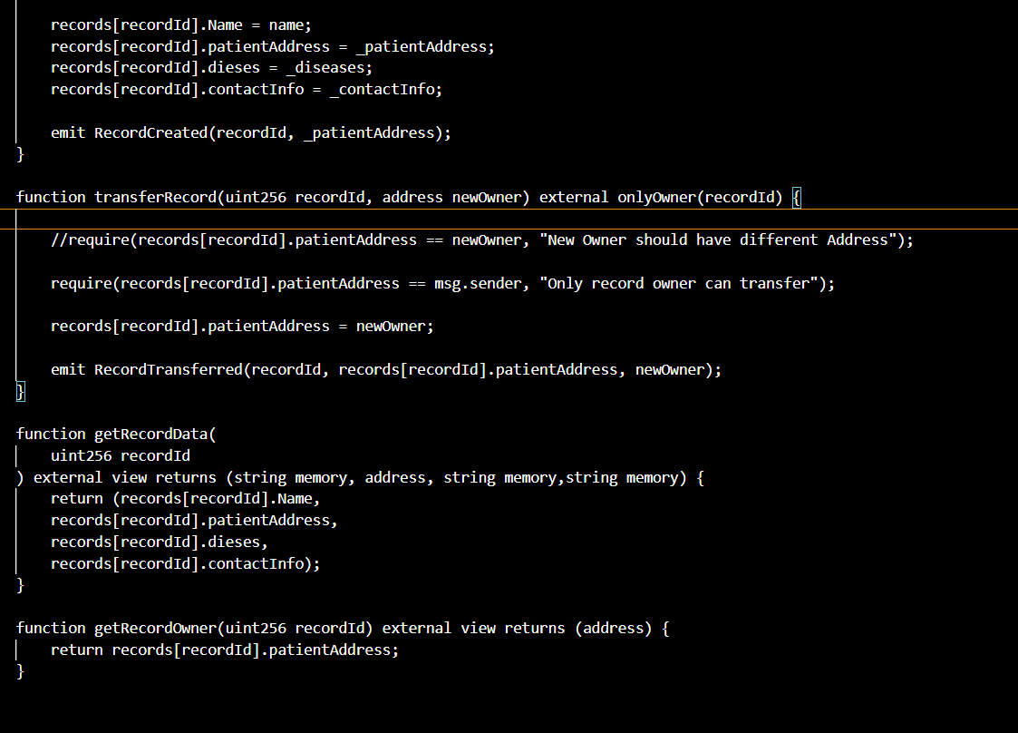**

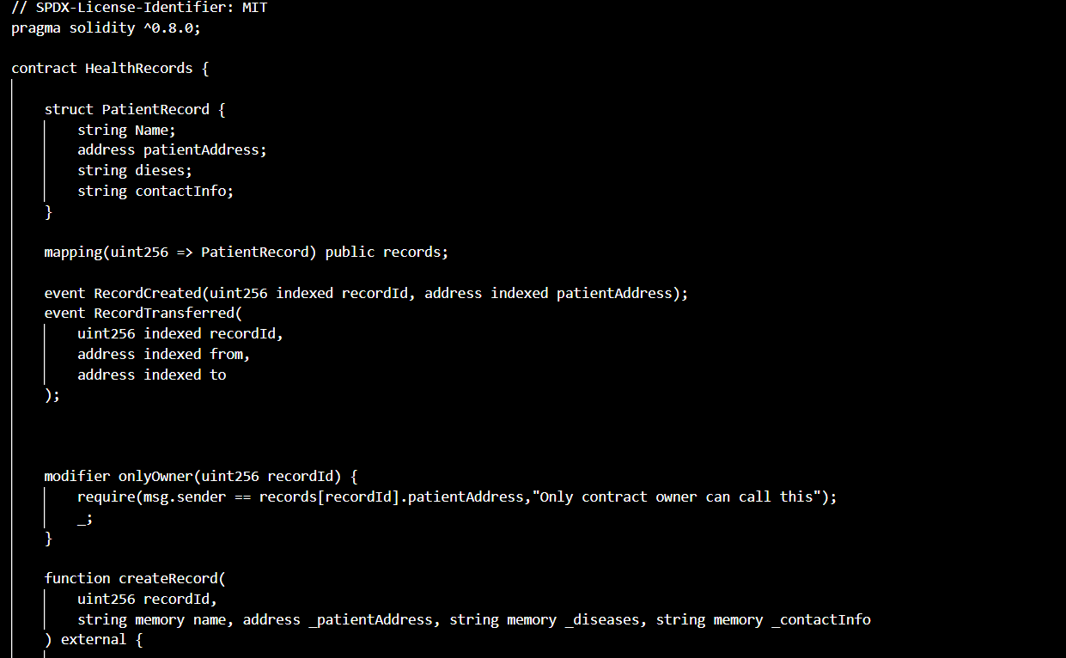

**13.2 GitHub & Project Demo Link:** [**https://drive.google.com/file/d/1K0Dcln2UxSL-8v18\_FQ8Lsh0OLjeq2Wy/view?pli=1**](https://drive.google.com/file/d/1K0Dcln2UxSL-8v18_FQ8Lsh0OLjeq2Wy/view?pli=1)